# Downstream Process

## Introduction (Stefanie)

The downstream process (DSP) is the second important step of the core manufacturing process and it aims to render the product to its final bulk formation. For this purpose, the clarified product is isolated, concentrated and polished in several steps and then packed in closed and transportable containers for fill-finish activities (John Joseph- Chapter 45).

For this case study work it was decided to physically segregate the main downstream activities in two separate suites, one for all activities prior to the virus filtration (nanofiltration) and one for all following activities, such as diafiltration, ultrafiltration and bulk filling. To highlight the separation, the rooms were labelled as 'DSP V+' and 'DSP V-', both corresponding to cleanroom class C. The rational for this design is to avoid any cross-contamination of the post-viral process material with potentially contaminated pre-viral material. The filled product is then fed through a material lock into a CNC room for bulk freezing before being stored in an adjacent storage room. Further process support activities, such as washing clean and staging, are to take place in a separate class D cleaning room adjacent to the 'DSP V+' room. The DSP is constantly monitored by three full-time staff members, two of whom work primarily in the pre-viral and one in the post-viral filtration zone. The following subchapters provide more in-depth information on the process, the premises and the equipment used in DSP.

## Plant on a page

In picture XY you can see the DSP plant on a page. This layout is based on the occupancy list and the process description. The product will be transported after the harvest in a mobile tote to the DSP V+ room. After the nanofiltration, the tote is transferred into the 'DSP V-’ room. Most buffers are pumped through the wall into the DSP rooms via aseptic connections. There (in-situ), all buffers are diluted with WPI inline. We can provide buffers on demand via the buffer management system. On the plant on a Page, the mixing valve represents the buffer management system. The same buffer management system is used for multiple unit operations. For each chromatography, however, there is a separate ÄKTA to increase the reproducibility and to be more flexible. A detailed process description can be seen below.

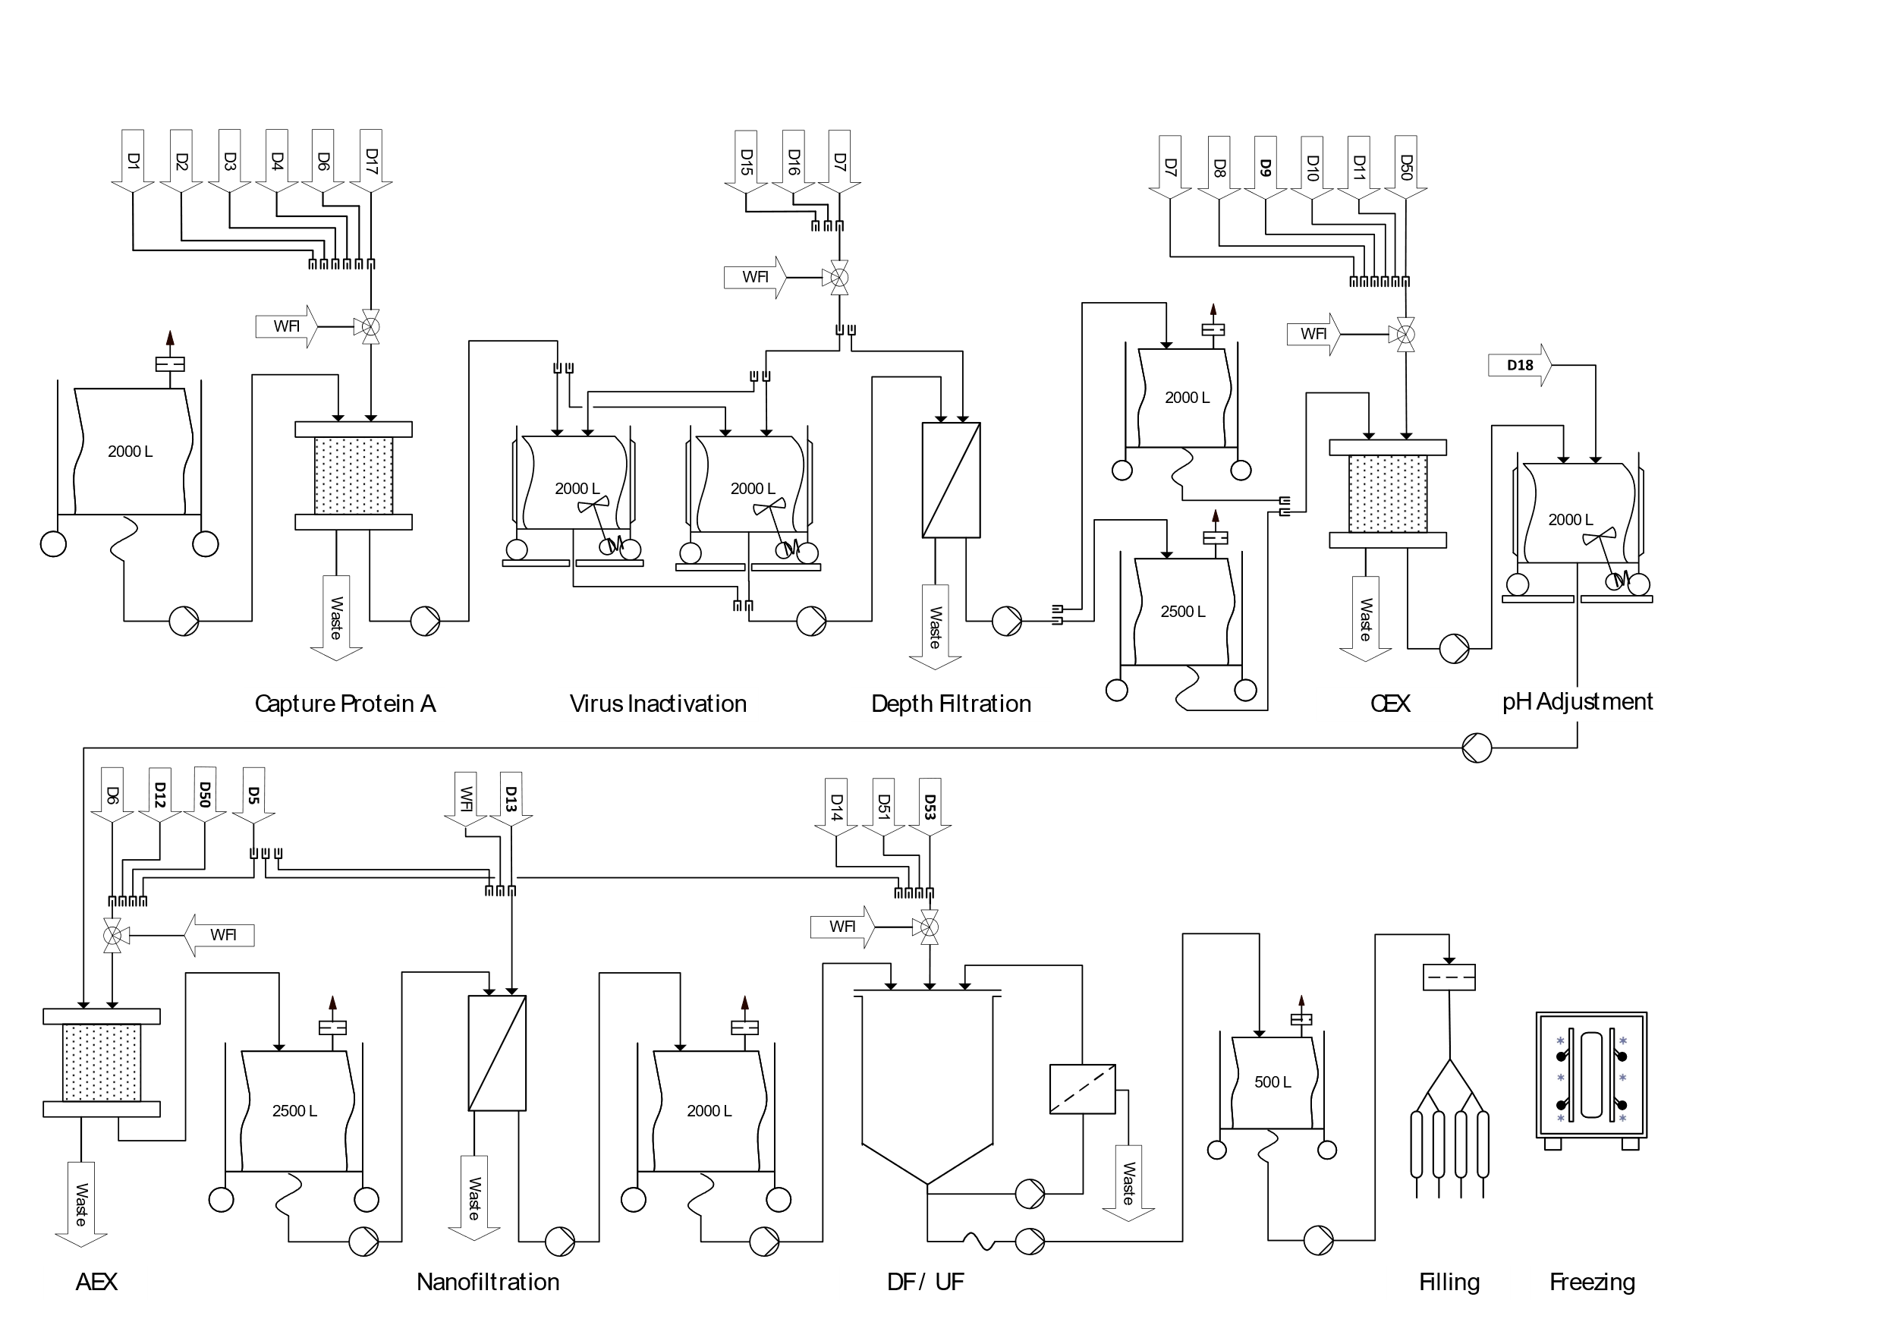

## Hako Bio room concept

One DSP line is planned for the purification of all four products, since the sequential USP approach provides a new batch each 3.7 days and the total DSP time is 3.8 days. Therefore, DSP can start processing a new batch as soon as the previous batch is in the filling and finishing phase. By temporally separating the processes, any contamination between products is avoided.

The product from the upstream processing is transported to the ‘DSP V+’ suite in a …… via an material airlock. For the first chromatography step (protein A capture) the material is introduced into a ÄKTA™ ready XL system, which is flushed and washed by different buffers provided directly from the buffer storage suites over an aseptic connection to a buffer management system. The eluted and purified product is collected in two 2000 L tank. The material is then aseptically connected to an Allegro™ MVP system for virus inactivation, which is also tied to the buffer management system. The same Allegro™ MVP system is used to pump the virus inactivated product through three interconnected depth filters (21 Stax filters– Explanation why?). The filtrate is collected in a 2000L and 2500L tank, which are subsequentially transported with a drive unit to a second ÄKTA™ ready XL system for cation exchange chromatography (CIEX). The purified product is eluted into a 2000 L tank and transported to a second Allegro™ MVP system for pH adjustment. This step is performed directly in the stirrable 2000 L tank and with buffers provided from the buffer suites in totes. This tank is then brought to a third ÄKTA™ ready XL system for anion exchange chromatography (AIEX). The eluted and purified product is collected in a 2000L tank. Both, CIEX and AIEX ÄKTA systems are managed by one buffer management system. The nanofiltration step is then performed on the same Allegro™ MVP system as the pH adjustment step, to which two nanofiltration capsules must be installed. The virus filtered product is collected in a 2000L tank, which is ready to be transported to the ‘DSP V-‘ room.

Once the product arrives in the viral free zone, it is further processed in a fully automated centrasette TFF system, which is also supplied with buffers by a buffer management system. The ultra- and diafiltrated material is directly connected to one depth filter (4 Stax filters – Explanation why?) and then collected in a 500 L tote. The purified bulk material is filled and transported with a trolley to the DSP freezing room and subsequent storage room.

The DSP virus positive room is connected to the buffer storage room and the USP room via airlock. A washing room for the cleaning of the equipment that are not single use is connected with airlock to the same room. A double airlock connected the virus negative room and the freezing room. Double airlock is required because of the passage from a class C room to a CNC area.

## Size and functions of DSP system (Stefanie)

The required equipment for the DSP rooms, their size and quantity are provided in tables X, X X, and X. The DSP relies heavily on single-use peripheral elements, such as connectors, aseptic transfer systems, tank liners and valves. Among the single-use equipment worth mentioning is the Allegro™ Connect Buffer Management System. Concentrated buffer solutions from the buffer cold storage room are coupled via an aseptic connection across the wall to the buffer management system in the DSP suites, where they are mixed with WFI and directly available to supply the equipment’s. Furthermore, three ÄKTA™ ready XL systems are located in the 'DSP V+’ rooms, each dedicated to one chromatography step. This setup allows more flexibility, especially in cases where upstream or downstream process times could be shortened and several ÄKTA™ ready XL systems could be operated in parallel. Finally, it is worth mentioning the Allegro™ MVP disposable system. This device is an excellent all-rounder for several DSP steps such as virus inactivation, pH adjustment, depth filtration and nanofiltration. Overall, the single-use approach generates higher operating costs and stronger dependence on suppliers. However, the increased flexibility and reduced facility footprint (no CIP/SIP, column packing room necessary) are especially advantageous for DSP. Furthermore, single-use systems are safer due to the decreased risk of microbial contamination, which is of absolute priority in a multiproduct facility.

Table 1: Required equipment for the DSP V+ area.

|  |  |  |  |  |
| --- | --- | --- | --- | --- |
| **DSP V+** | | | | |
| **Equipment** | **Information** | **Quantity** | **Size (WxDxH)**  **[m]** | **Photo** |
| Allegro™ Connect Buffer Management System | In-line buffer dilution system  Energy consumption :230V | 2 | 1.12x1.12x1.99 | Allegro™ Connect Buffer Management System |
| [2000 L Jacketed Cubical Tank with Load Cell](https://pall.hakobio.com/Portfolio/7fde819d-4c6e-4f9f-aa31-90174e6097fd) | Stainless Steel Tank for Use with Magnetic Mixer Drive Unit | 6 | 1.78x1.39x2.65 | 2000 L Jacketed Cubical Tank with Load Cell |
| 2500 L Jacketed Cubical Tank with Load Cell | Stainless Steel Tank for Use with Magnetic Mixer Drive Unit | 1 | 1.75x1.66x2.29 | 2500 L Jacketed Circular Tank with Load Cell |
| ÄKTA™ ready XL - | Single-use chromatography system  Flow rates from 45 to 3500 L/h | 3 | 1.28x1.15x1.95 | ÄKTA™ ready XL single-use system from Cytiva |
| [ReadyToProcess™ 32L columns from Cytiva](https://pall.hakobio2.com/Portfolio/c424a252-e5e4-4856-be4c-4c1617a5e52e) | Chromatography columns for protein A capture | 1 | 0.7x0.7x0.63 |  |
| [ReadyToProcess™ 32L columns from Cytiva](https://pall.hakobio2.com/Portfolio/c424a252-e5e4-4856-be4c-4c1617a5e52e) | Chromatography columns for CIEX | 1 | 0.7x0.7x0.63 |  |
| [ReadyToProcess™ 32L columns from Cytiva](https://pall.hakobio2.com/Portfolio/c424a252-e5e4-4856-be4c-4c1617a5e52e) | Chromatography columns for AIEX | 1 | 0.7x0.7x0.63 |  |
| Allegro™ MVP Single-use system with Quattreflow pump | Multipurpose applications  Energy consumption :230V | 2 | 0.96x1.28x1.13 |  |
| [Magnetic Mixer Drive Unit](https://pall.hakobio2.com/Portfolio/b48ebc94-36b1-4e9b-b1dd-0f6fa3c8309d) | Robust single-use mixing system | 3 | 0.4x0.82x1.03 |  |
| Stax™ Disposable Depth Filter High Chassis- | Chassis for up to 10 Large Stax Disposable Depth Filters - 21 Depth filters used per batch in total | 3 | 0.8x1.15x1.93 | Ein Bild, das drinnen enthält.  Automatisch generierte Beschreibung |
| Kleenpak™ Nova Capsule NP6 | For 100L to 1000L  Virus removal filters used with MVP Single-use system | 2 | 0.24x0.24x0.35 | Ein Bild, das Topf enthält.  Automatisch generierte Beschreibung |

Table 2 Required equipment for the DSP V- area.

|  |  |  |  |  |
| --- | --- | --- | --- | --- |
| **DSP V-** | | | | |
| **Equipment** | **Information** | **Quantity** | **Size (WxDxH) [m]** | **Photo** |
| Allegro™ Connect Buffer Management System | In-line buffer dilution system  Energy consumption :230V | 1 | 1.12 x 1.12 x 1.99 | Allegro™ Connect Buffer Management System |
| Fully Automated Centrasette TFF system | Tangential Flow Filtration System | 1 | 0.8x1.5x1.5 |  |
| [Single-Use TFF Module](https://pall.hakobio2.com/Portfolio/60b5bac3-6af5-42bb-9b08-921ce0f03b38) | Single-Use Module for Concentration/  Diafiltration | 1 | 0.23x0.25x0.09 | Single-Use TFF Module |
| [Stax™ Disposable Depth Filter Medium Chassis](https://pall.hakobio2.com/Portfolio/a382cc57-fefc-4d29-a72a-1f2f5284603c) | Medium chassis for up to 5 Stax Disposable Depth Filters - 4 Depth filters used per batch in total. | 1 | 0.8x1.15x1.31 | Ein Bild, das drinnen enthält.  Automatisch generierte Beschreibung |
| Bulk Filling System |  | 1 | 0.69x1.61x1.58 | Ein Bild, das Gerät enthält.  Automatisch generierte Beschreibung |
| Allegro™ 500L Plastic Tote with Trolley | Collapsible | 1 | 1.22x0.87x1.23 | Allegro™ 500 L Plastic Tote with Trolley |
| Bulk Filling Trolley |  | 1 | 1.02x0.66x1.15 | Bulk Filling Trolley |
| [Magnetic Mixer Drive Unit](https://pall.hakobio2.com/Portfolio/b48ebc94-36b1-4e9b-b1dd-0f6fa3c8309d) | Robust single-use mixing system | 1 | 0.4x0.82x1.03 |  |

Table 3 Required equipment for the DSP Freezing area.

|  |  |  |  |  |
| --- | --- | --- | --- | --- |
| **DSP Freezing** | | | | |
| **Equipment** | **Information** | **Quantity** | **Size (WxDxH) [m]** | **Photo** |
| Ross.pFTU large-scale | Plate-based freeze-thaw unit with control unit | 1 | 3.17x1.39x2.25 | RoSS.pFTU Large-Scale |

Table 4 Required equipment for the DSP Cleaning area

|  |  |  |  |  |
| --- | --- | --- | --- | --- |
| **DSP Freezing** | | | | |
| **Equipment** | **Information** | **Quantity** | **Size (WxDxH) [m]** | **Photo** |
| Sterilization Autoclave GSS-L 6710 EC1 | Steam Sterilizer | 1 | 0.66x1.00x0.70 | Sterilization Autoclave GSS-L 6710 EC1 |